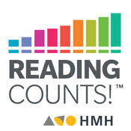
READING COUNTS AT CASTILLE

Reading Counts is a reading comprehension and reading incentive program. Students are able to improve their reading skills by reading books and taking comprehension quizzes on the computer at school. Students are rewarded for their reading efforts. For the past 18 years, the Reading Counts program has been a big success. This year we want to continue that success.

How does Reading Counts work?
Your child chooses a book to read from home, their classroom, the school library, city library, or bookstore. They read the book at school or at home. After completing the book they notify their teacher. Their teacher will give them time to take a comprehension quiz on the computer in the classroom or computer lab. If your child passes the comprehension quiz, they earn points. They can then choose another book to read and earn more points.

Can my child read any book, do all books have quizzes?
Reading Counts is a web-based program which means that we have access to over 80,000 quizzes. While there may not be quizzes for all books, 95% of the books you will find in our school library, classroom library, and local bookstore have quizzes. If you would like to know if a book has a quiz and/or how many points a book is worth, your child’s teacher can look up the information through their Scholastic link, or you can look for the information at home by going to and searching for books https://readingcountsbookexpert.tgds.hmhco.com and search by title or author. This link is also posted on the Castille website.

When and where can my child take quizzes?
Quizzes can only be taken at school, during the school day, under the supervision of a teacher. The Reading Counts program is available in the classroom and in the computer lab.

How does my child earn rewards?
Each time your child passes a quiz they earn points. Longer, more challenging books will be worth more points, shorter books with a lower lexile level will be worth less points. The points accumulate with each quiz that is passed. At the end of each month students are honored at a morning assembly.

Reading Counts Guidelines
*All Reading Counts quizzes must be taken during school hours under the supervision of a teacher.
*Reading Counts quizzes can only be taken for books read during the current school year. Quizzes cannot be taken for books read during the summer.
*Quizzes can be taken for books read in full. They may not be taken for partially read books or for movies watched, based on a book.

If a quiz is taken that does not follow the above guidelines it may result in points being removed.

**A HUGE thank you to the Castille PTA for their incredible support of the Reading Counts program. The PTA funds all awards for the program, as well as, the ongoing licenses to use the program. It is your support of the PTA that makes a difference and makes the Reading Counts program possible.

Reading Counts Coordinator
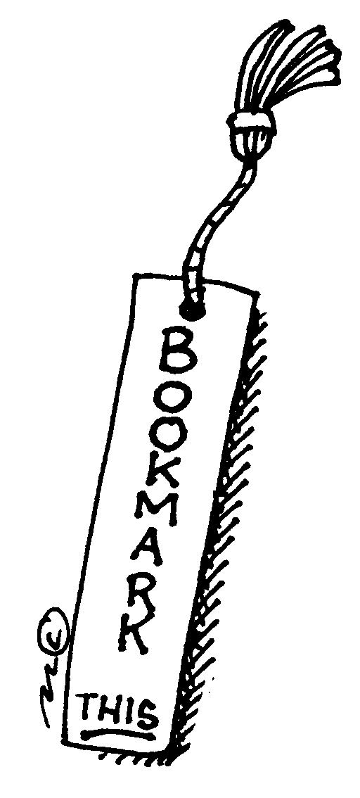
Karen Kauo

